**Link to our Repo**

**Aquatix**

https://bitbucket.org/team5c/hidden-leaf

**Contributions**

* Designing web page for Exhibits
* Multiple Events fetching from Database to Exhibit page
* Business logic to hold selected events
* Client : Exhibits page with multiple events

**Screenshot of our Home page:**

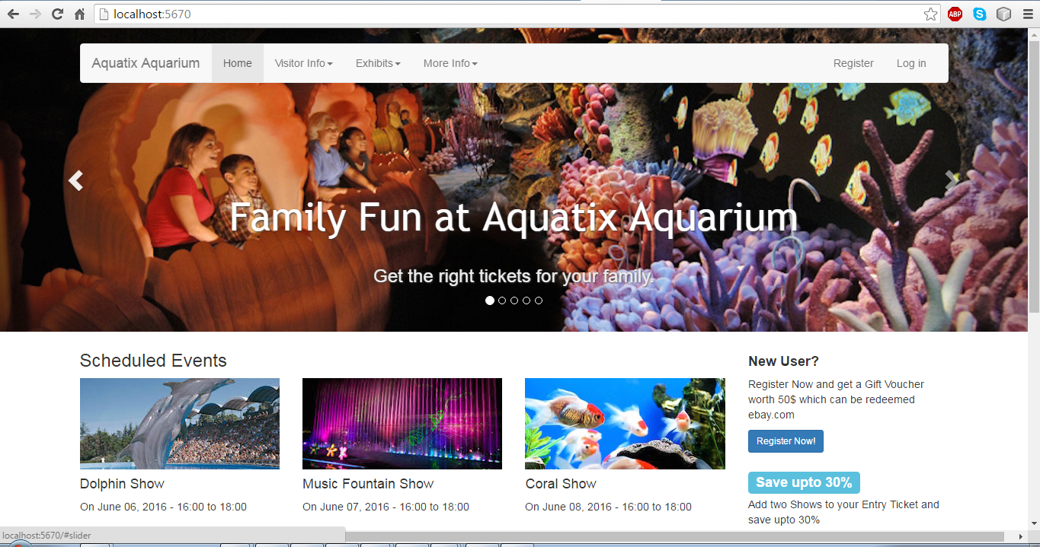

**References**

All the data and images used in our application have been acquired from ***Google images***